**ITPC 115 - Assignment No. 1: 15 GitHub Command with Activity (By Two’s)**

**Partner: Mr. Rosales, Dan Xcel G.**

**Assignment of Mr. Gurtiza, Jazzver Jamieson O.**

**1. Create Local Repository**

**Command:** git init

**Description:** Initializes a new Git repository in the current folder.

**Output:** Initialized empty Git repository in D:/Gurtiza-Library-tps-Exam/.git/

**Screenshot:**

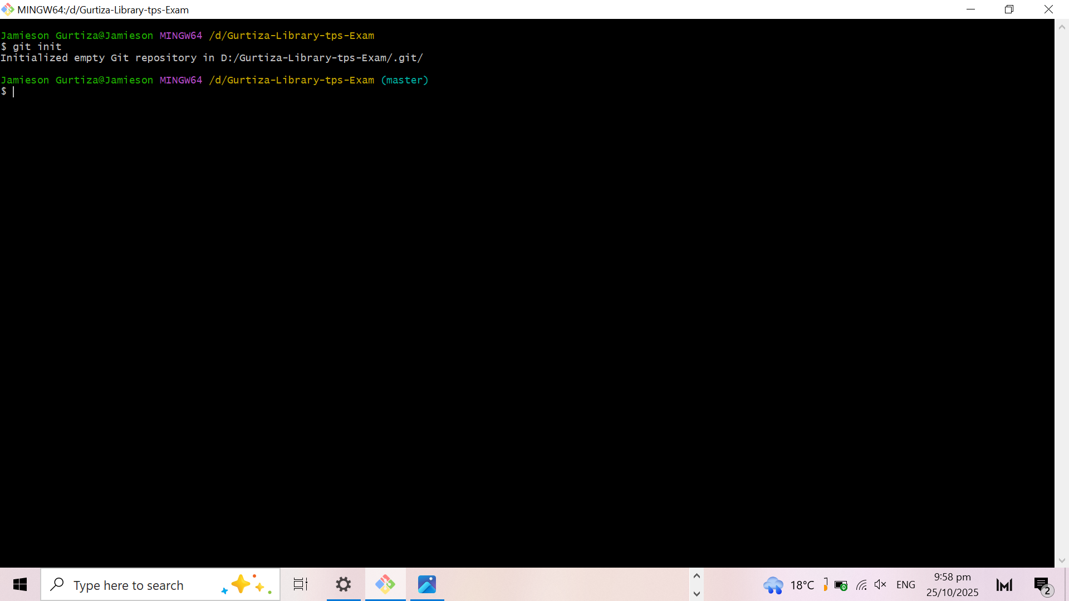

**2. Add Files to the Staging Area**

**Command:** git add .

**Description:** Adds changes (new or modified files) to the staging area before committing.

**Output:** No error, and this means that files are staged successfully.

**Screenshot:**

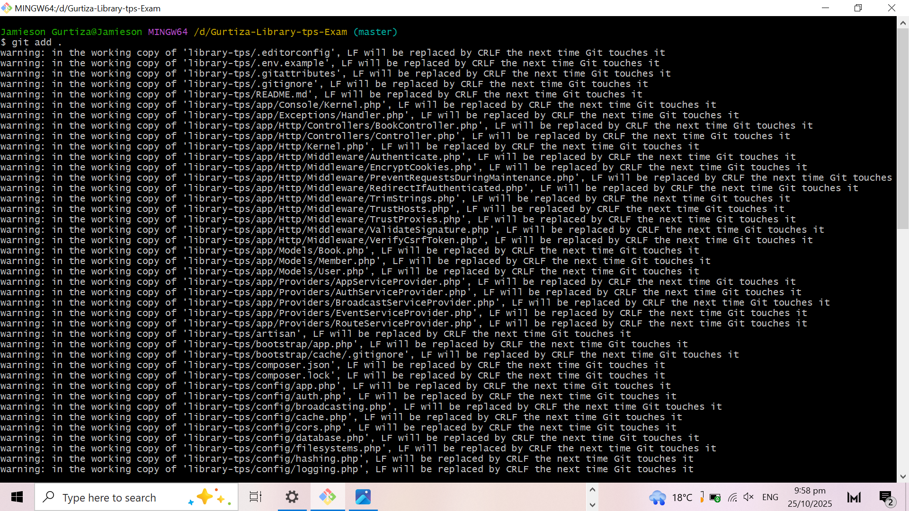

**3. Commit Changes**

**Command:** git commit -m "Initial commit"

**Description:** Saves the staged changes to the local repository with a message.

**Output:** [main (root-commit) c480ab1] Initial commit

**Screenshot:**

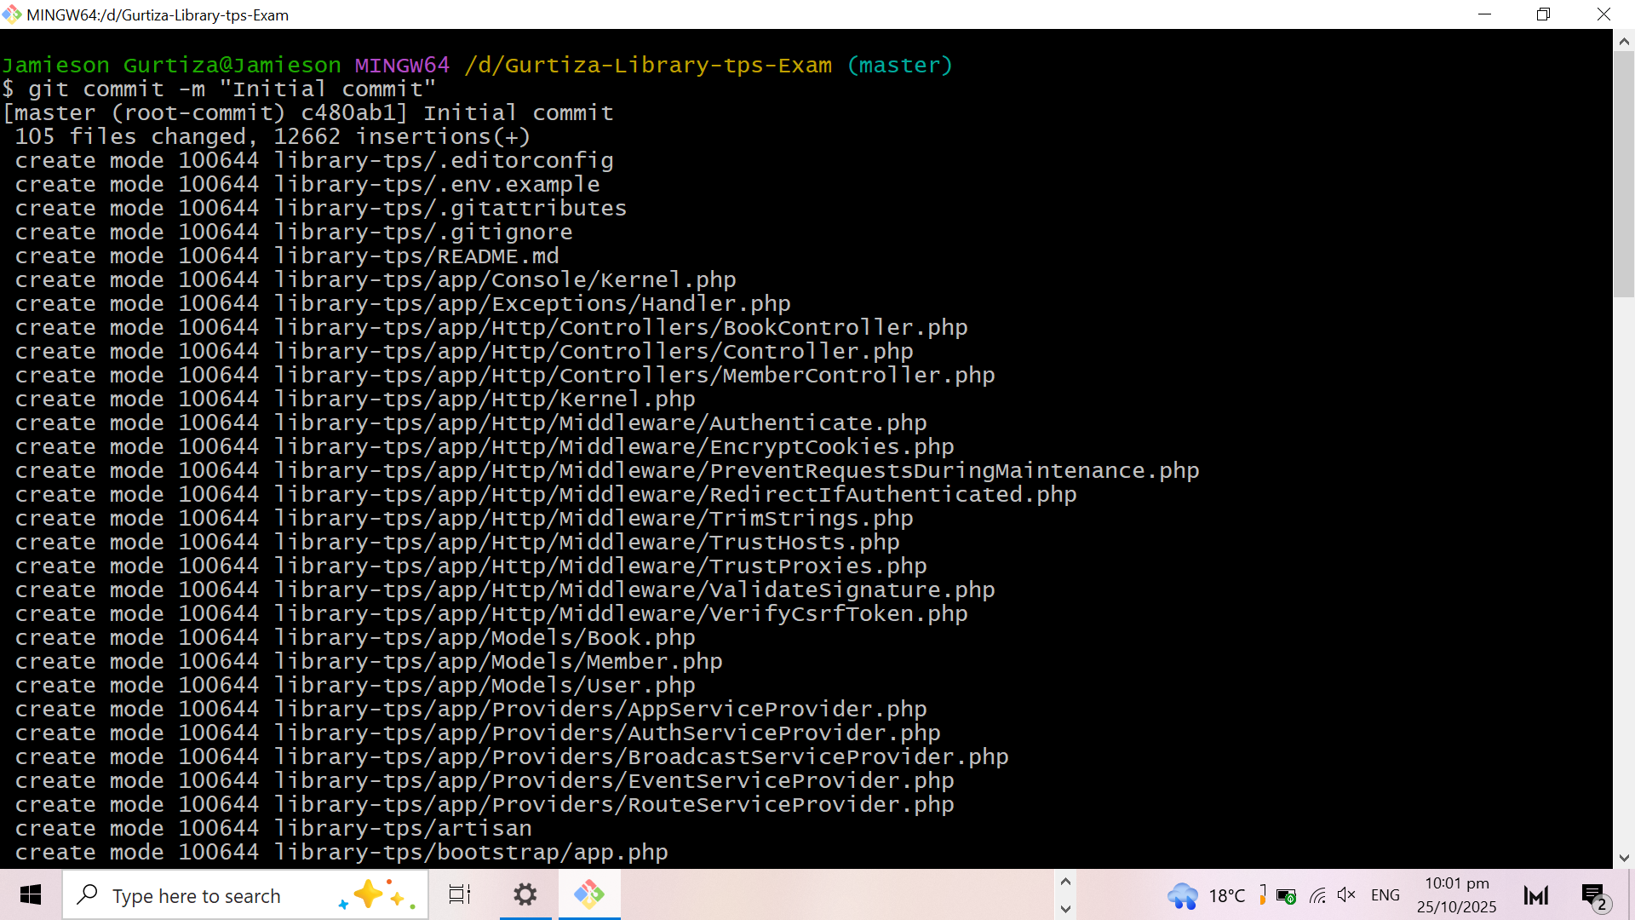

### **4. Configuring User Identity**

**Command:**

git config --global user.name "Jamieson"

git config --global user.email "ogawajazzver@gmail.com"

**Description:** Sets your Git username and email for commits.

**No output** (successful setup).

**Screenshot:**

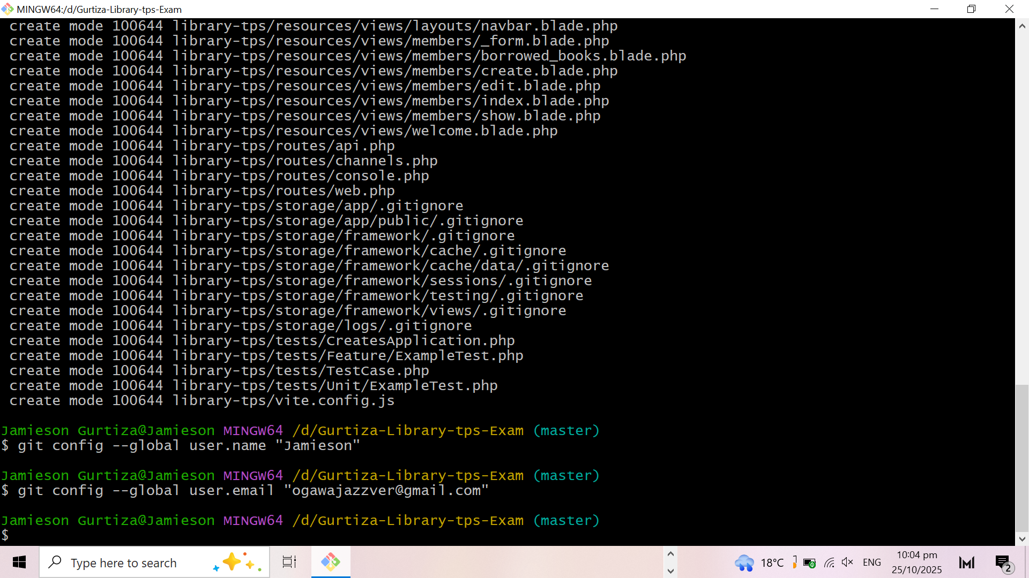

## **5. Connect to Remote Repository**

**Command:** git remote add origin https://github.com/Jamieson/your-repo.git

**Description:** It links the local repository to a remote GitHub repository so you can push your commits online.

**No output** because the connection was successful.

**Screenshot:**

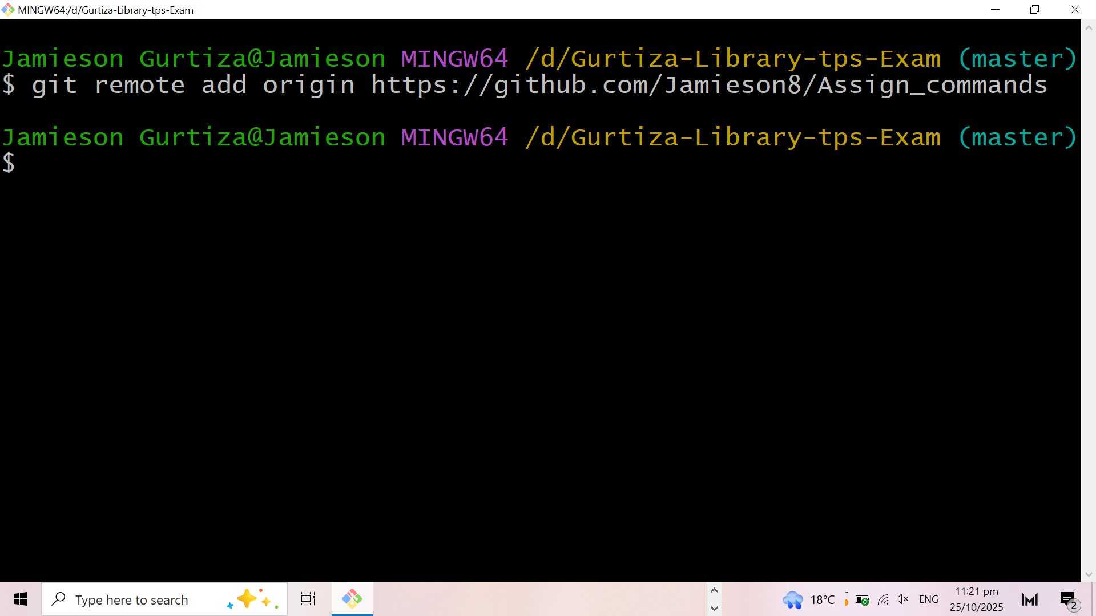

## **6. Rename and Push Main Branch**

**Command:**

git branch -M main  
git push -u origin main

**Description:** Renames the current branch to 'main' and uploads it to the connected GitHub repository.

**Output:**

Branch 'main' set up to track remote branch 'main' from 'origin'.

**Screenshot:**

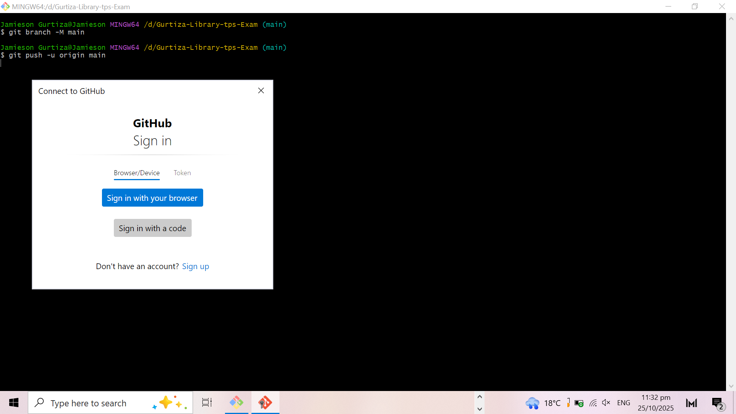

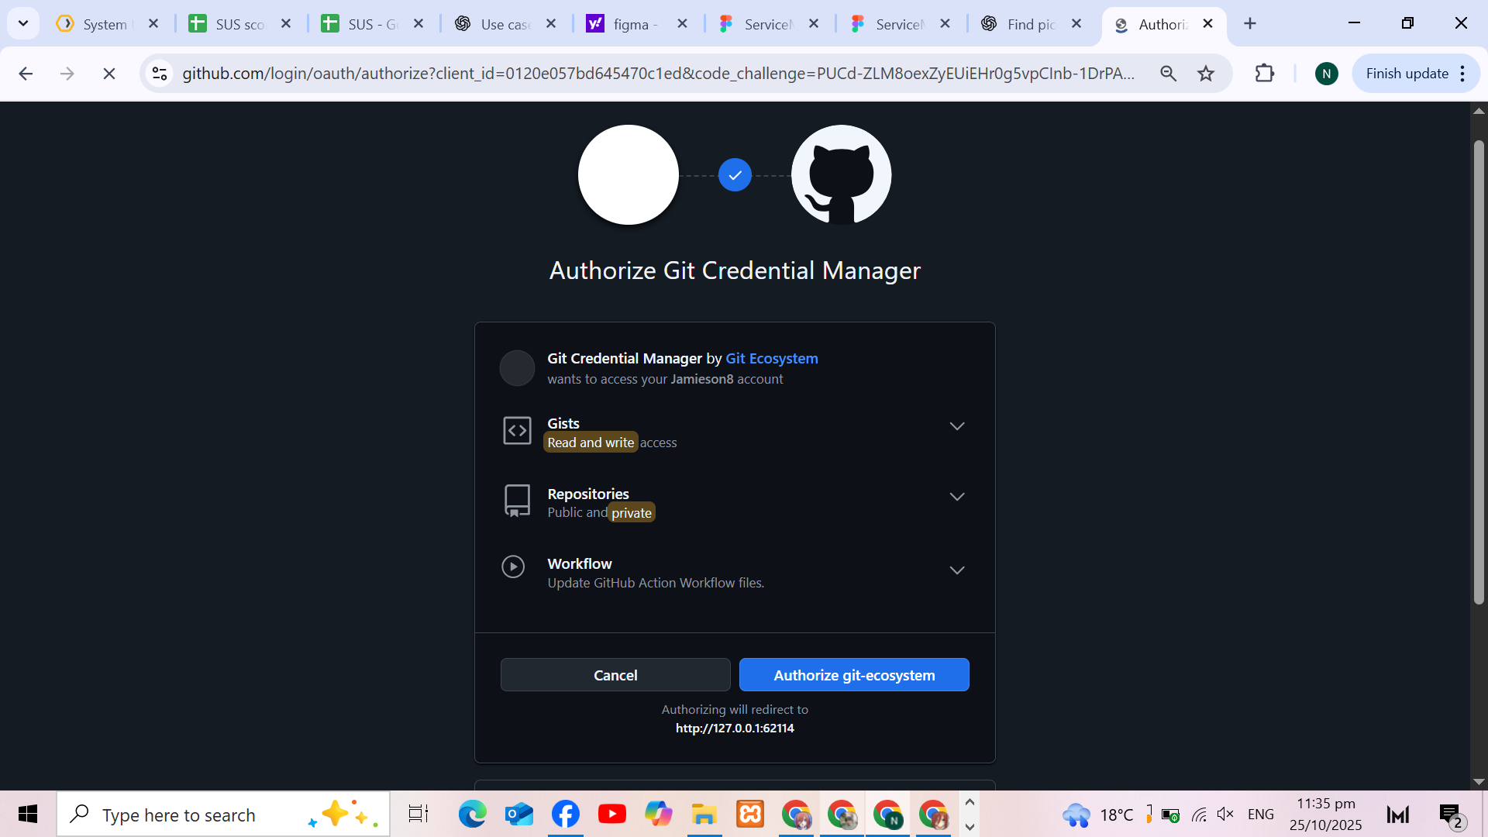

## **7. Clone Repository (Partner’s Repo)**

**Command:** git clone https://github.com/D-3xcel/Git1

**Description:** Downloads an existing repository from GitHub to your local machine.

**Output:**

A new folder is created with the repository’s contents.

**Screenshot:**

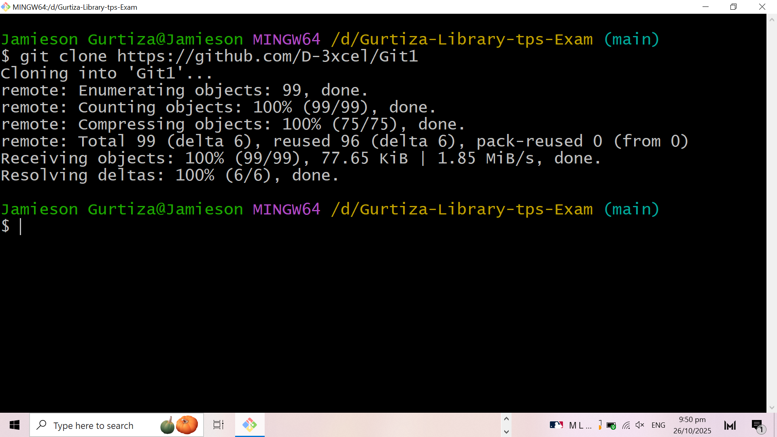

## **8. Create and Switch Branch**

**Command:** git checkout -b feature-branch

**Description:** Creates a new branch and switches to it for separate development.

**Output:**

Switched to a new branch 'feature-branch'.

**Screenshot:**

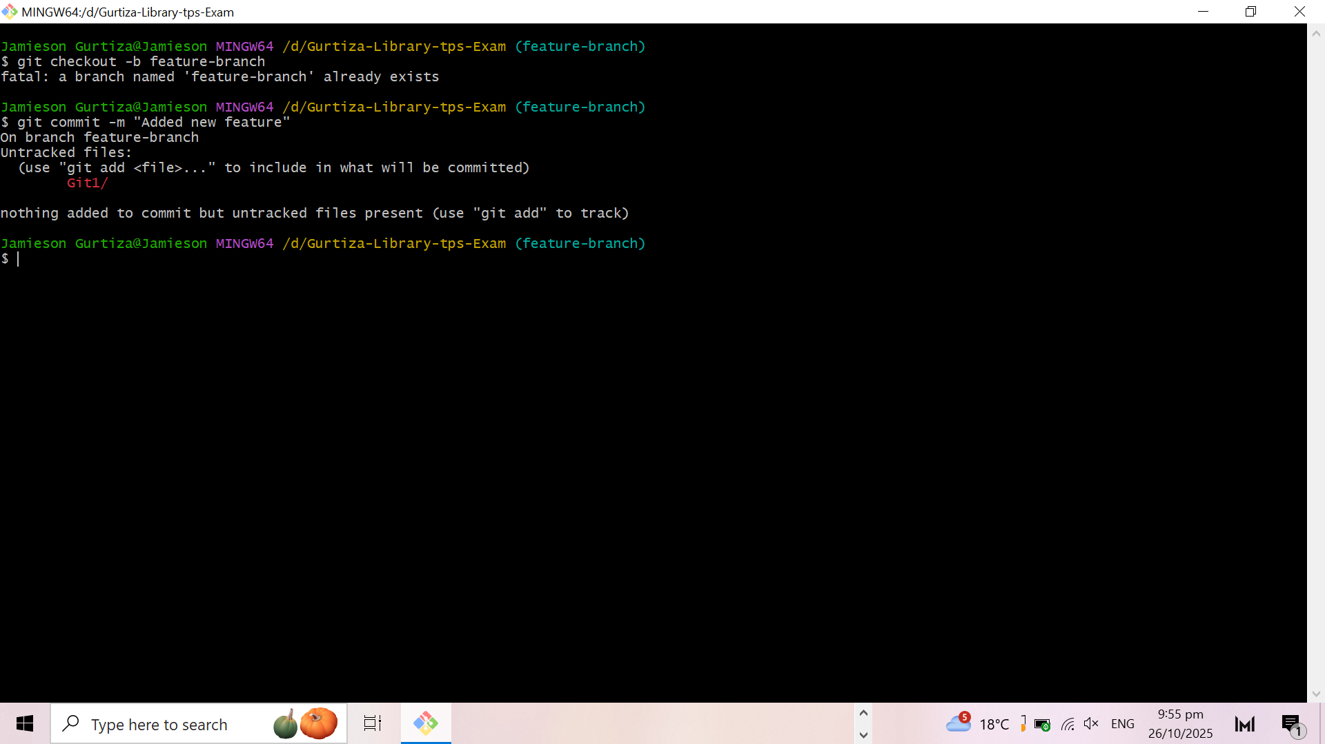

## **9. Make and Commit Changes in Branch**

**Command:**

git add .  
git commit -m "Added new feature"

**Description:** Stages and commits new changes made in the branch with a descriptive message.

**Output:**

Added new feature.

**Screenshot:**

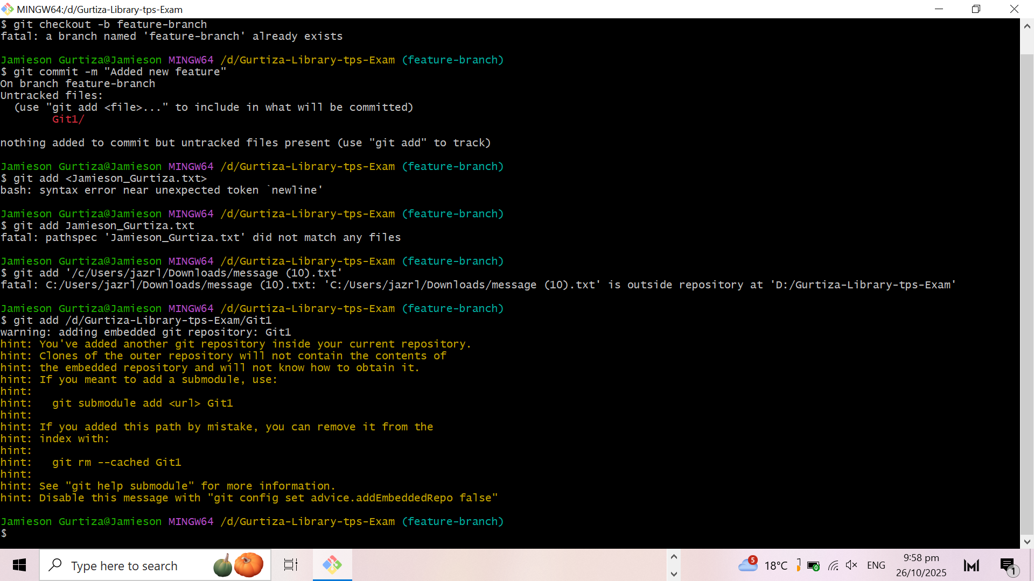

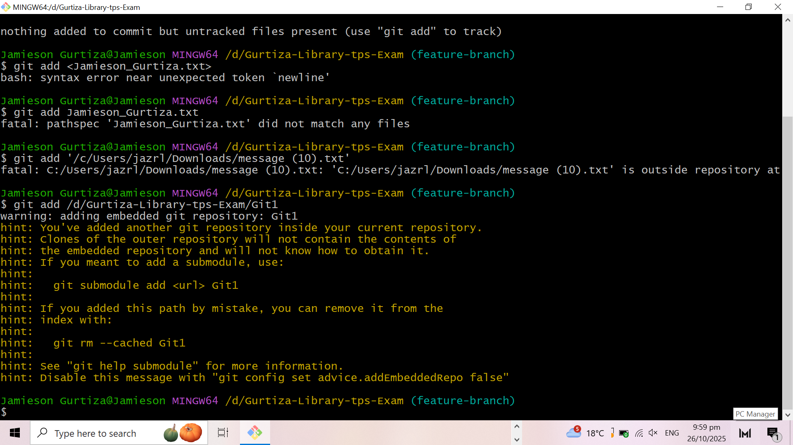

## **10. View and Compare Branches**

**Command:**

git branch  
git diff main feature-branch

**Description:** Lists all branches and shows the differences between two branches.

**Output:** Displays the current branches and any line-by-line differences.

**Screenshot:**

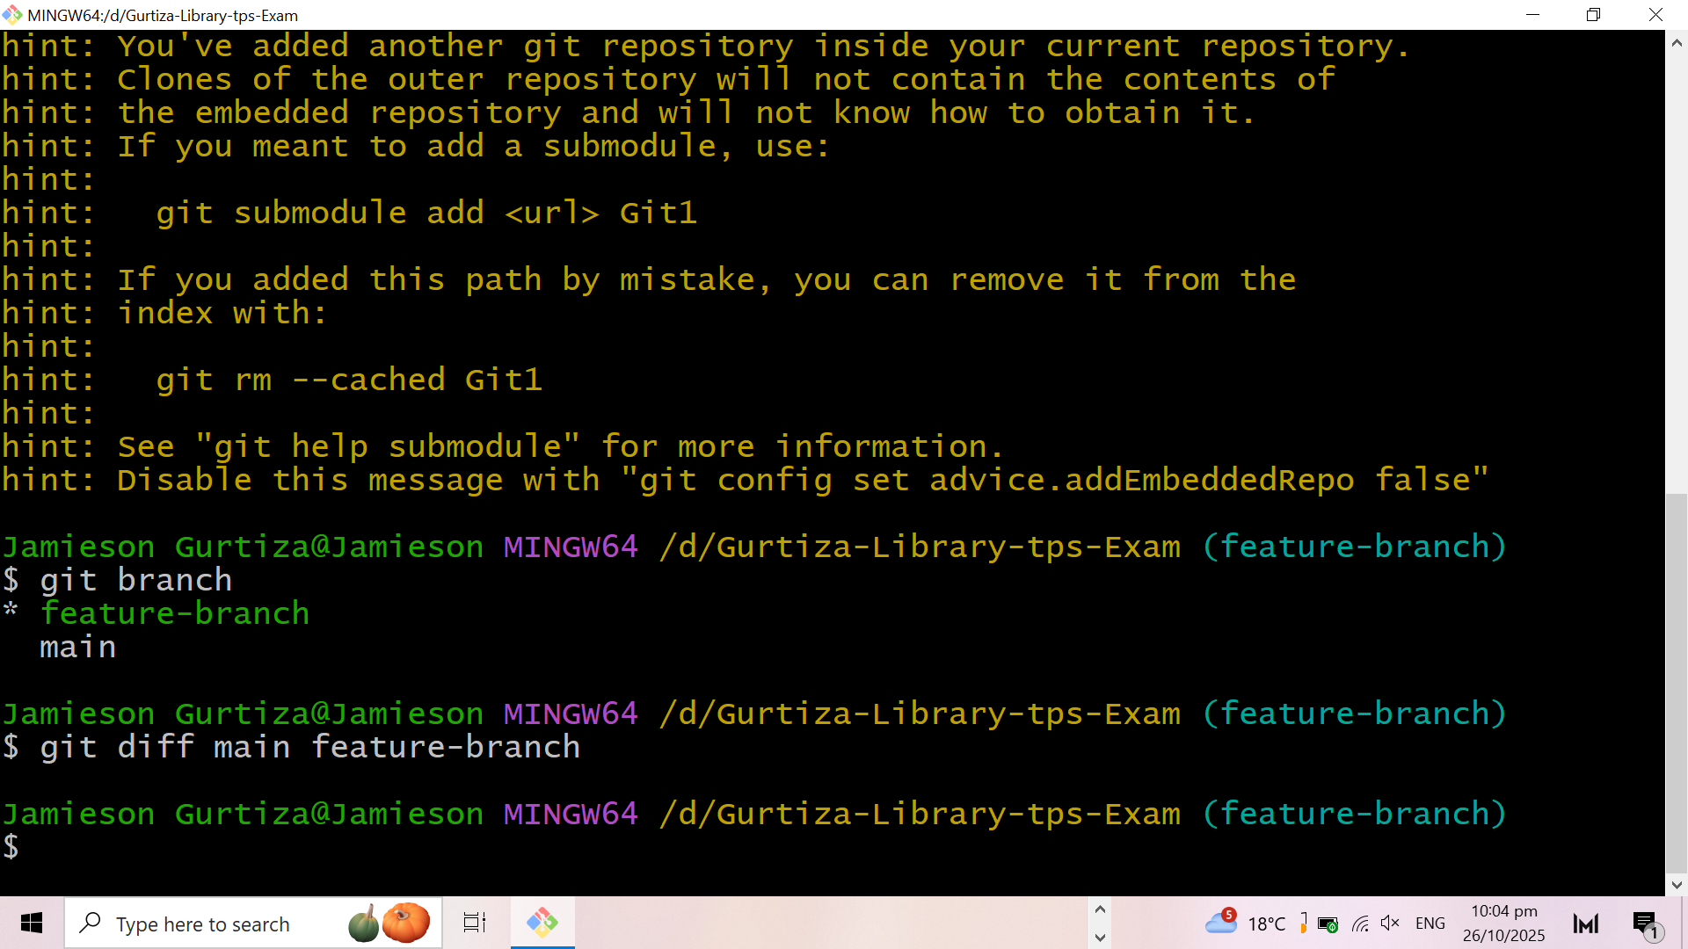

## **11. Merge Branch with Main**

**Command:**

git checkout main  
git merge feature-branch

**Description:** Combines all changes from the feature branch into the main branch.

**Output:**

A Git 1

Switch to branch ‘main’

Already up to date

**Screenshot:**

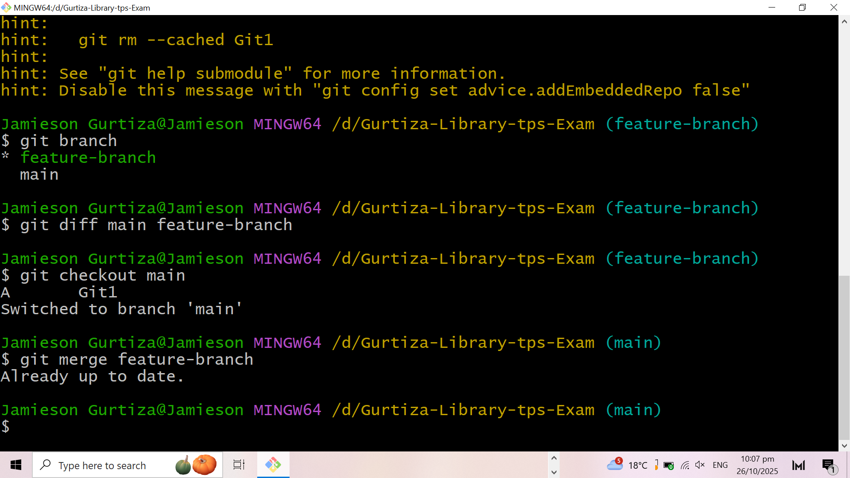

## **12. Delete a Branch After Merge**

**Command:** git branch -d feature-branch

**Description:** Deletes a local branch after its changes have been successfully merged.

**Output:**

Deleted branch feature-branch (was c480ab1).

**Screenshot:**

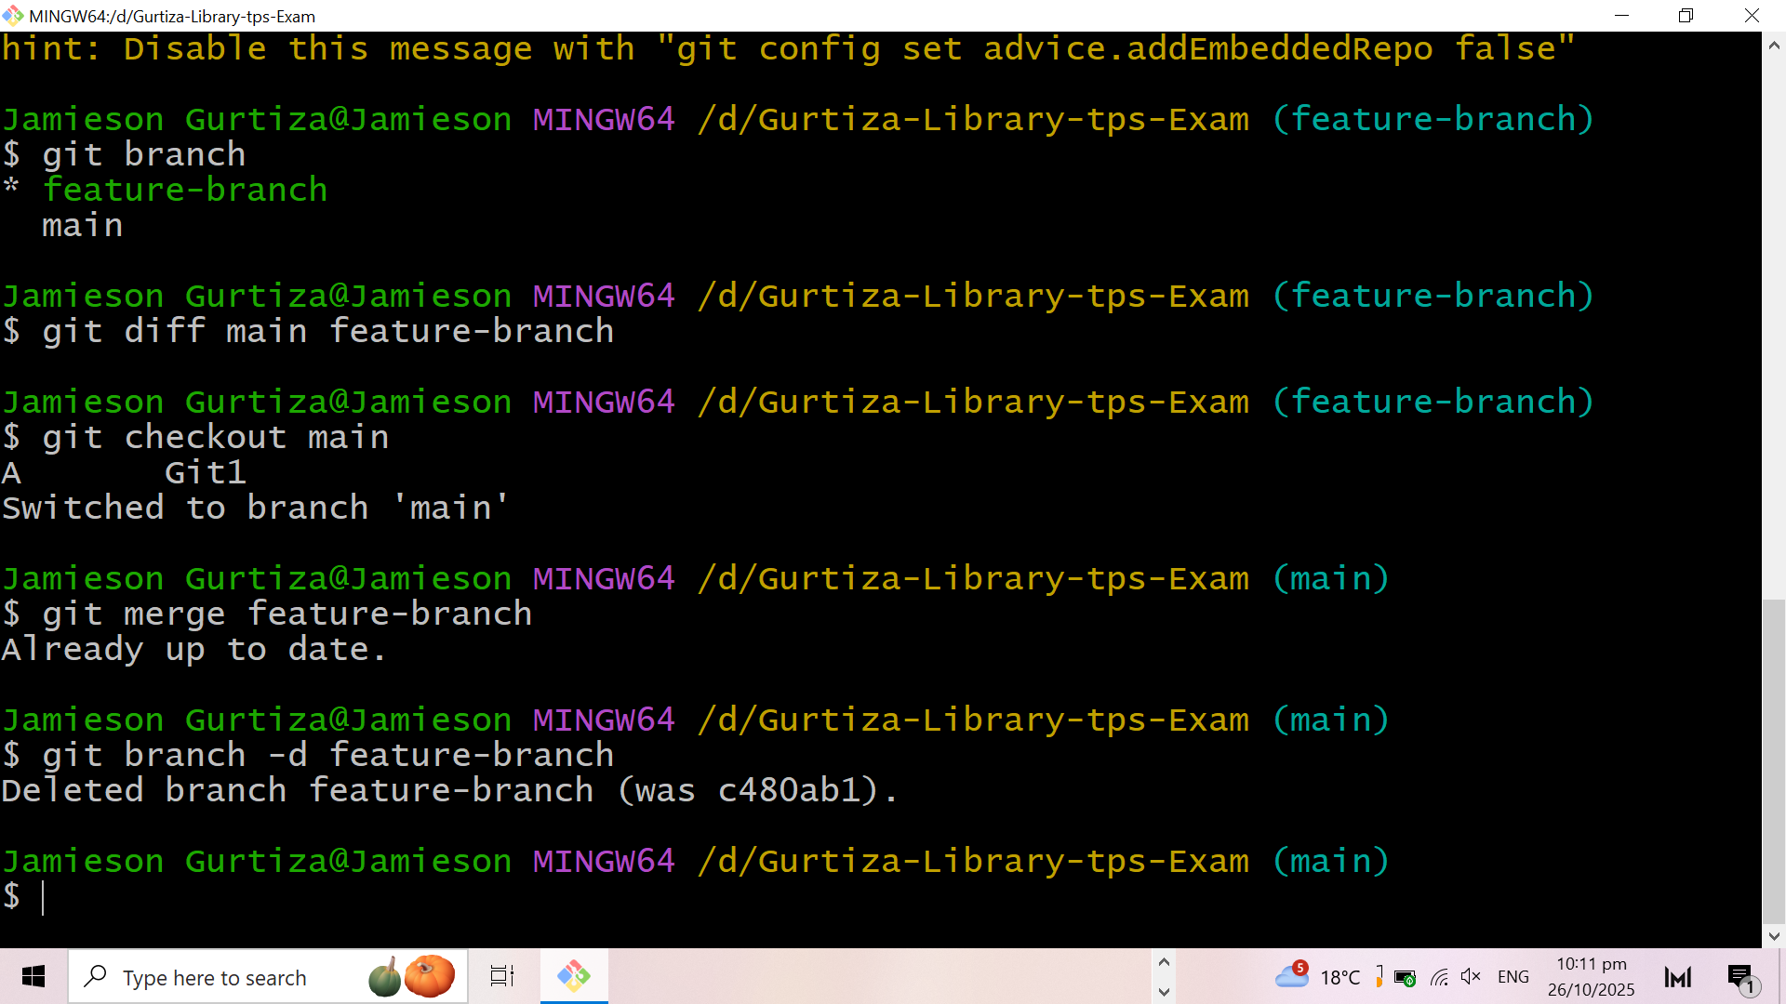

## **13. Fetch and Pull Updates from GitHub**

**Command:**

git fetch  
git pull

**Description:** Downloads updates from the remote repository and merges them into your local repository.

**Output:**

* [new branch] main -> origin/main

git branch --set-upstream-to=origin/<branch> main

**Screenshot:**

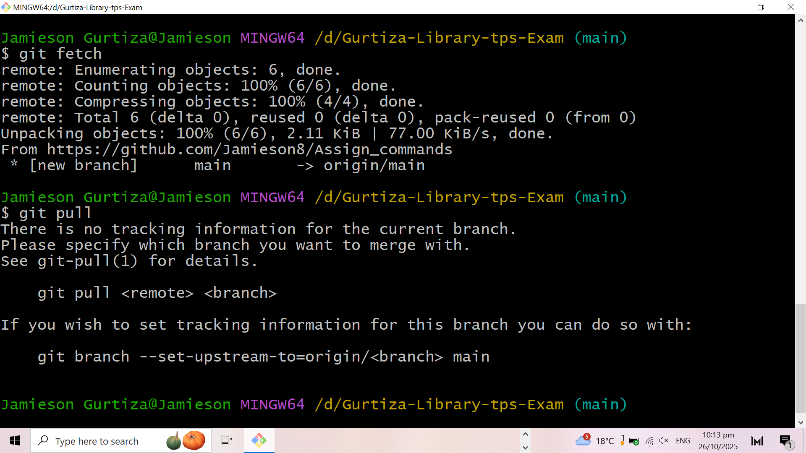

## **14. View Remote Repository Information**

**Command:** git remote -v

**Description:** Displays all remote connections (URLs) linked to your local Git repository.

**Output:**

origin https://github.com/Jamieson8/Assign_commands (fetch)  
origin https://github.com/Jamieson8/Assign_commands (push)

**Screenshot:**

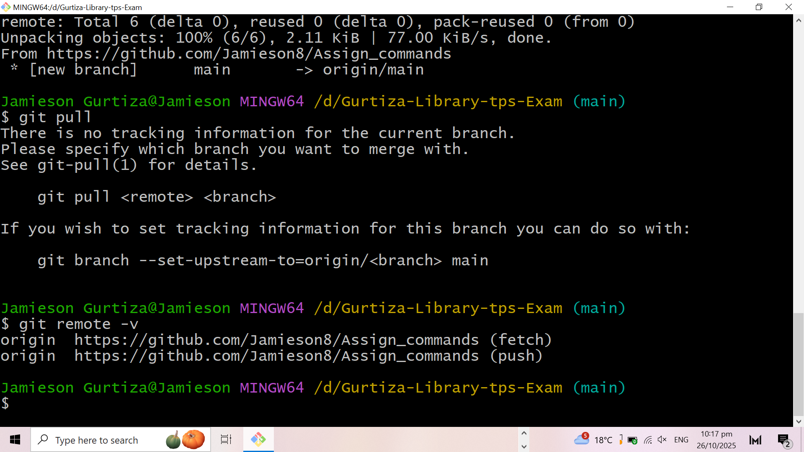

## **15. Undo or Restore Changes**

**Command:**

git restore Git1  
git reset HEAD filename  
git revert <commitID>

**Description:** Reverts a file to a previous version, unstages files, or undoes a commit safely.

**Output:**

Changes reverted successfully.

**Screenshot:**



